

Aptech North Karachi Campus| CPISM-First Semester | October 12,2022

DEVELOPER’S GUIDE



|  |  |  |
| --- | --- | --- |
|  |  |  |
| **Advisor/Teacher/Instructor** | SIR MUHAMMAD ADEEL | |
| **Batch Code** | 2407F3 | |
| **Serial Number** | **Enrollment Number** | **Student Name** |
| **1** | Student1592427 | MUHAMMAD OMER NADEEM |
| **2** | Student1592425 | MUHAMMAD HAMMAD |
| **3** | Student1589950 | SHAYAN ANWAR . |
| **4** | Student1592430 | UMAIR ALI . |
| **5** | Student1590807 | MUHAMMAD DANIYAL KHAN . |

# Acknowledgement

The First, we are thankful to our God (Allah S.W.T) who give us strength to solve this Challenging task and improve our skills with the help of our will power.

The Second, we would like to express our special thanks of gratitude to our respectable and honorable teacher Sir Adeel Habib, who helped us and trained us a lot in finalizing this project within the given time frame, valuable counselling and assistance for the accomplishment of this Project.

After all, we are especially thankful to the Aptech eProject team, who give us immense pleasure to address us about eProject. They provide us a new way of learning, which would value add the existing course material that has been provided to us.

# eProject Synopsis

**Game Verse** is a gaming website that provides reviews, news, live streaming, and community features. It aims to be a central hub for gamers, offering up-to-date content and a seamless user experience.

*

# PROJECT STRATEGY REVIEW

|  |  |  |  |  |  |  |
| --- | --- | --- | --- | --- | --- | --- |
|  | |  |  | | | |
| **PROJECT MANAGEMENT** | | **PROJECT TITLE** | **PROJECT STRATEGY** | | | |
| **SERIAL #** | **TASK** | Tangoline | **START DATE** | **TASK DURATION** | **MEMBER NAME** | **STATUS** |
| 1 | Design Home Page,  About Page  &  Our Developer Team Page | 20  November  2024 | 5 day | Omer Nadeem  **Student1592427** | DONE |
| 2 | Design Game Store  Design All Game Store Detailing Page | 22  November  2024 | 2 days | Omer Nadeem  **Student1592427** | DONE |
| 3 | Design Gaming Product Store and his Detailing Pages | 28  November  2024 | 6 day | Omer Nadeem  **Student1592427**  Shayan Anwar  **Student1589950** | DONE |
| 4 | Design Contact Page,  Contact Form | 01 December  2024 | 4 day | Omer Nadeem  **Student1592427**  MUHAMMAD DANIYAL KHAN  **Student1590807** | DONE |

# 

# REQUIREMENTS OF THE PROJECT WHICH ASSIGNED US FROM APTECH

Welcome to eProjects

Dear Student,

It gives us immense pleasure to address you about eProjects. This is a new way of learning, which would value add the existing course material that has been provided to you.

Kindly find attached the eProject Specification.

In case of any queries do write back to us.

**Your Project/Assignment Start date is:    19-Nov-2024**

**Your Project/Assignment End date is:      19-Dec-2024**

You need to complete your project and submit the following by the end-date.

1. **Submit a video clip demonstrating the working of your Project.**

1. **Create Single Page Website.**

1. Working Application

a.        Source Code

b.        Compiled Code

1. eProject Report

#   eProject Report should comprise-

qAcknowledgements

qeProject Synopsis

qeProject Analysis

qeProject Design

nDFD’s

nFlowCharts

nProcess Diagrams

nDatabase Design / Structure

qScreen Shot’s

qSource Code with Comments

qUser Guide

qDeveloper’s Guide

nModule Descriptions

# DEVELOPER’S GUIDE

When user starts the website, the below page will show on the screen

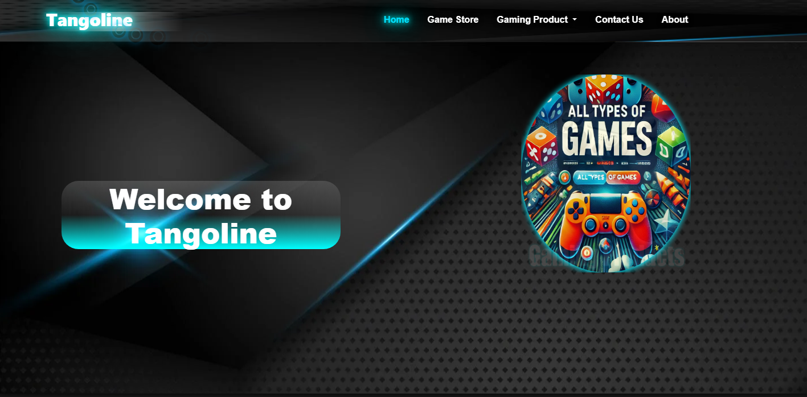

When home.html page opens then user can go to multiple pages through the navbar link.

Let suppose when the user press on about then the following page will be displayed infront of him

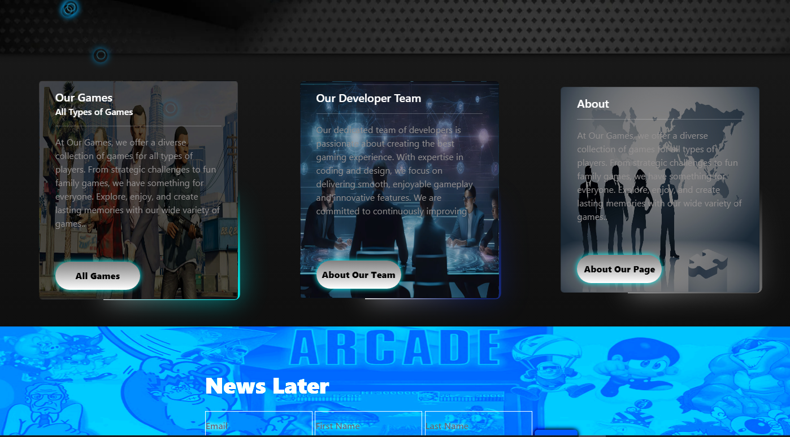

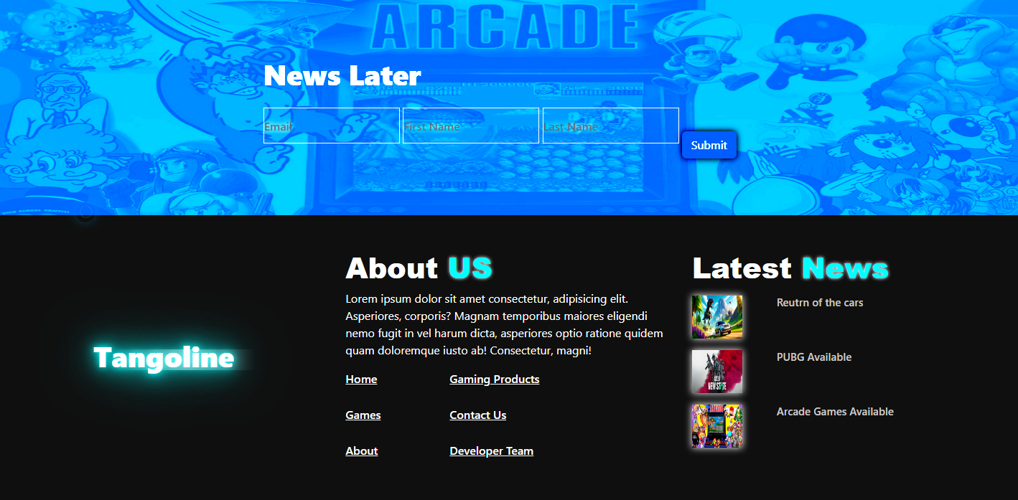

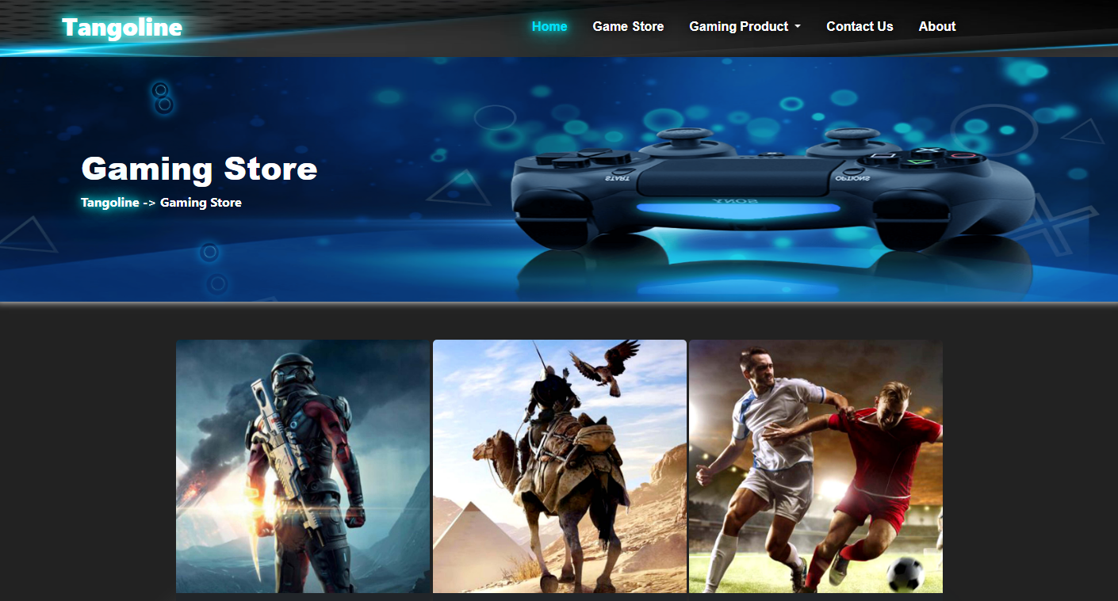



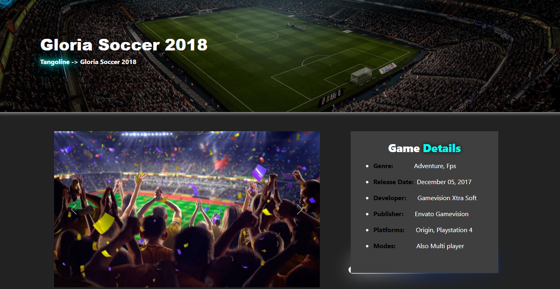

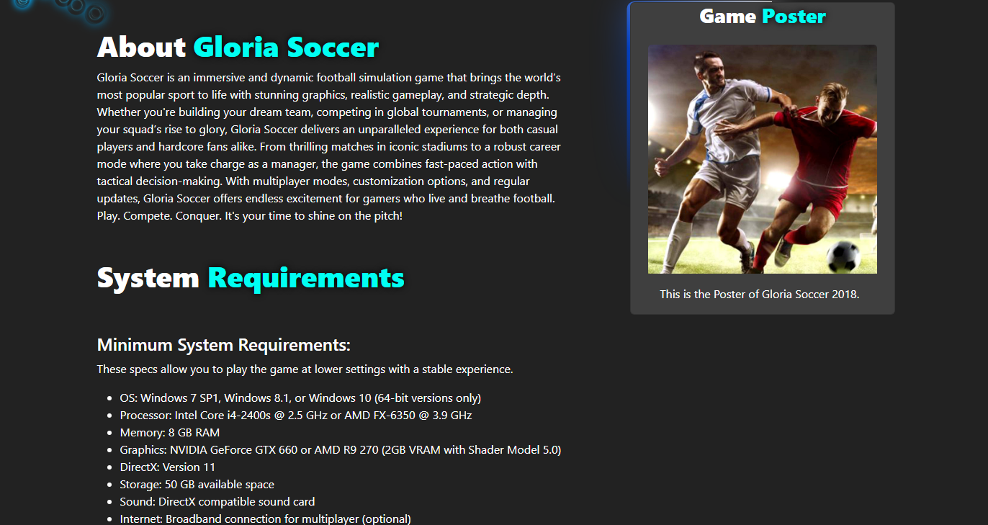



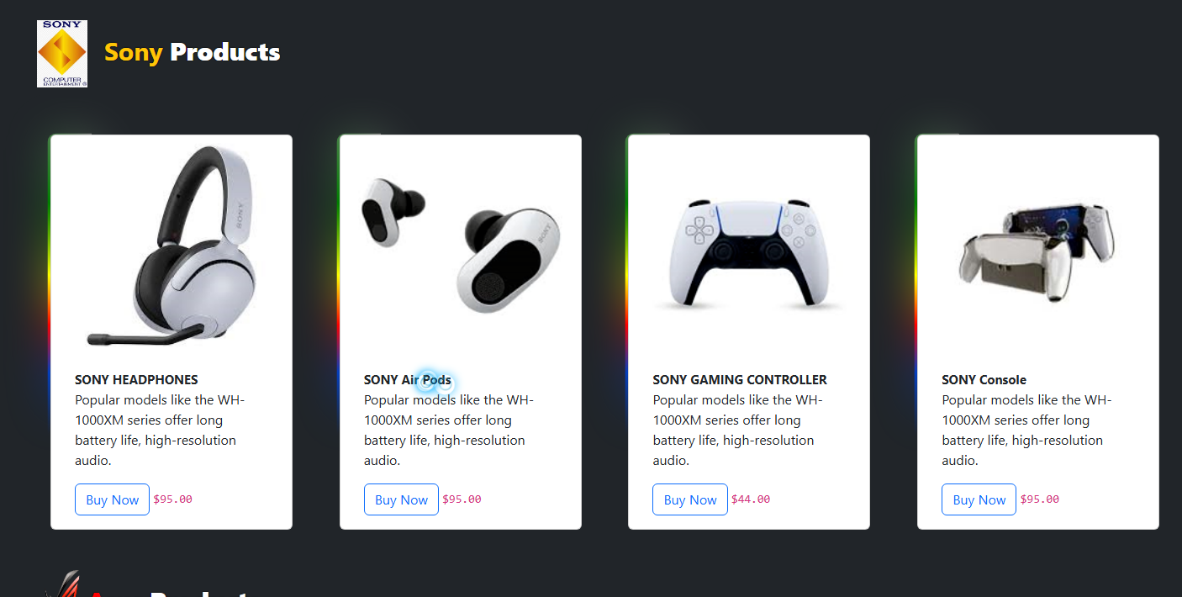



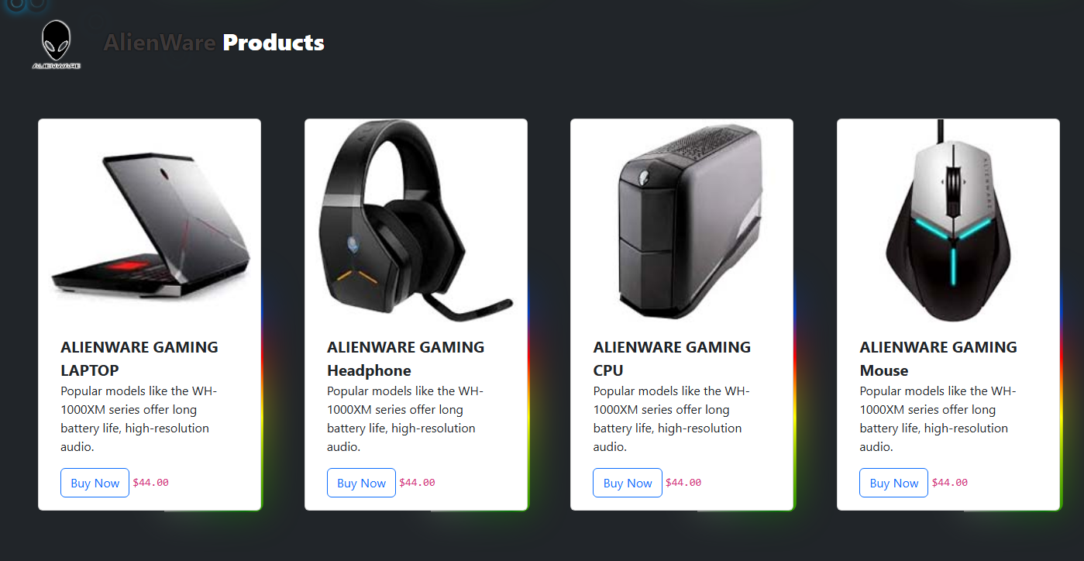

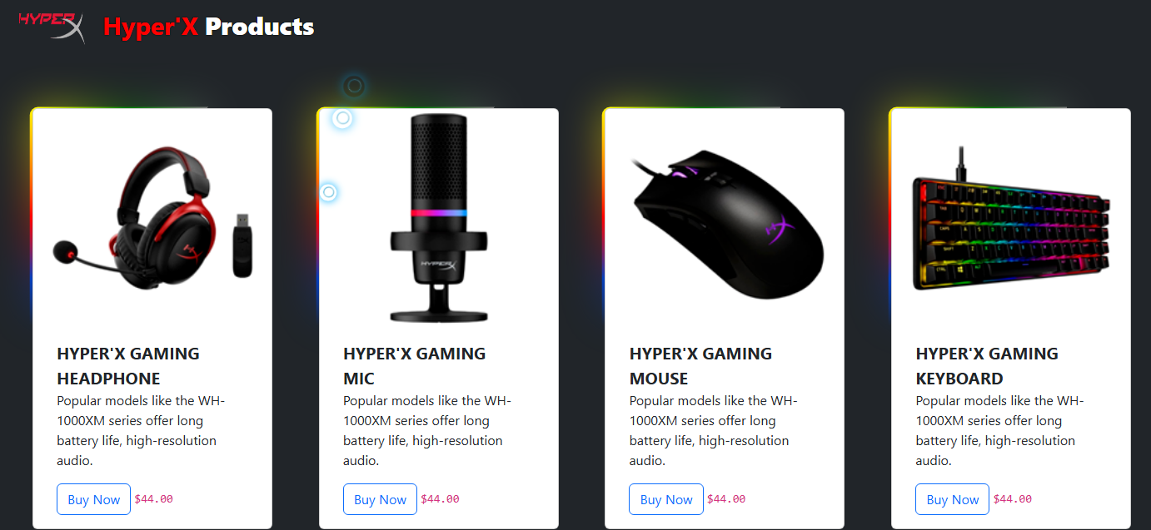

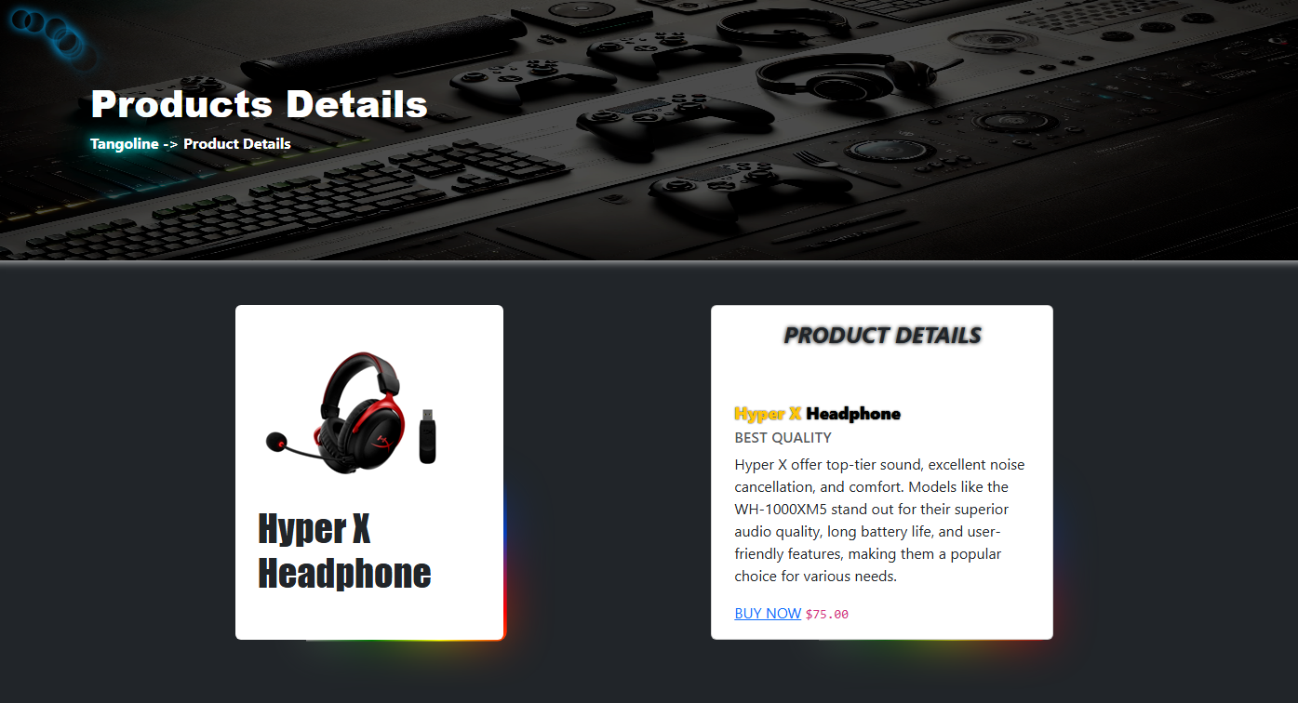

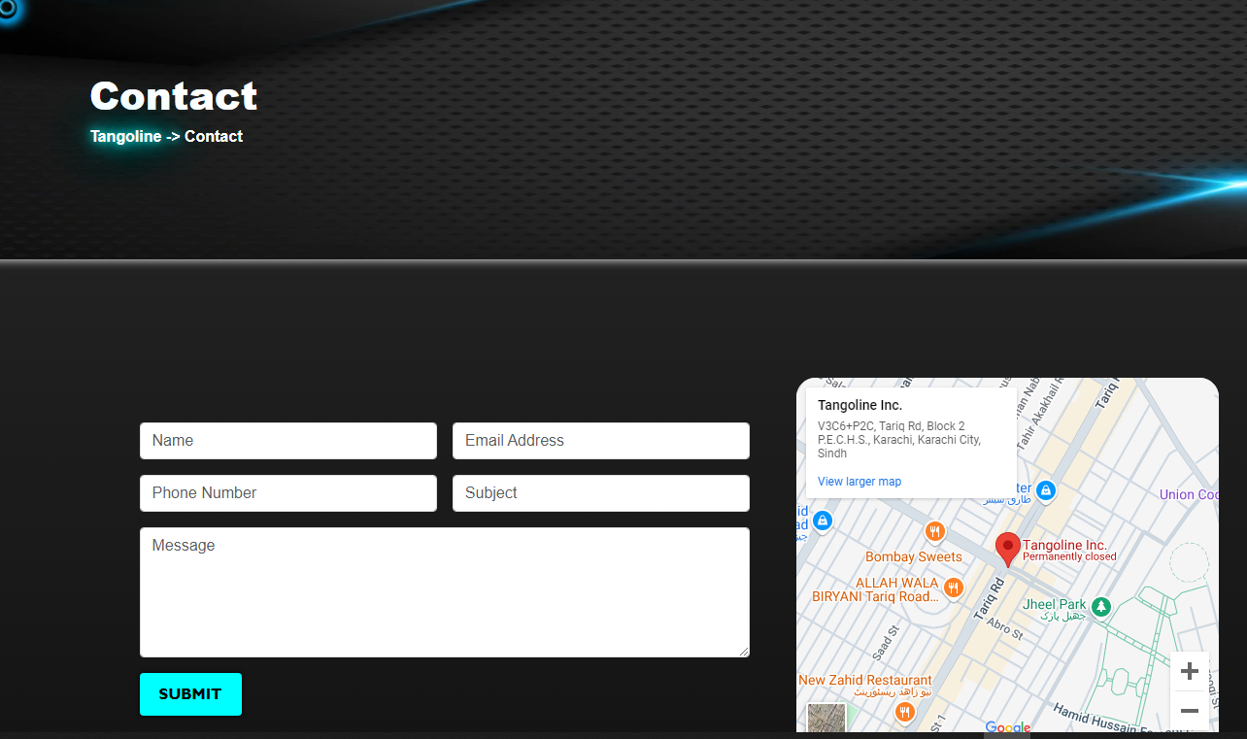



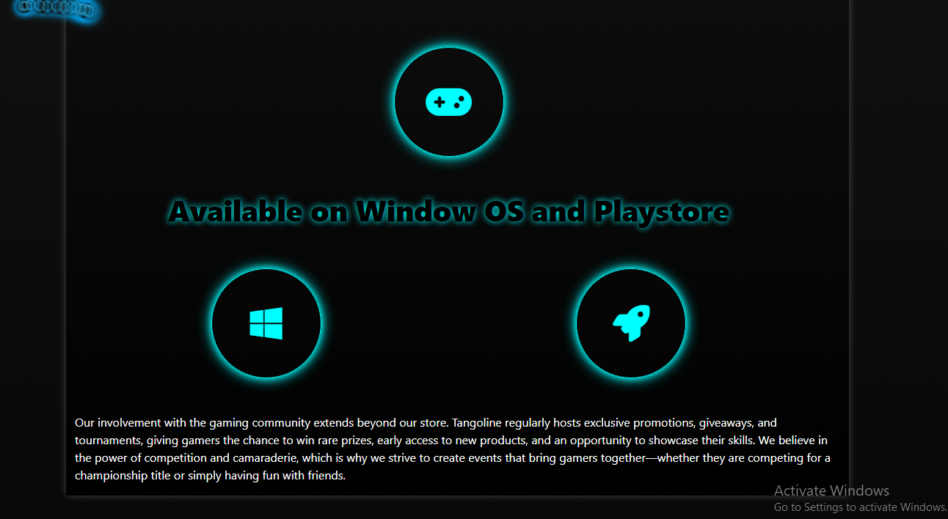

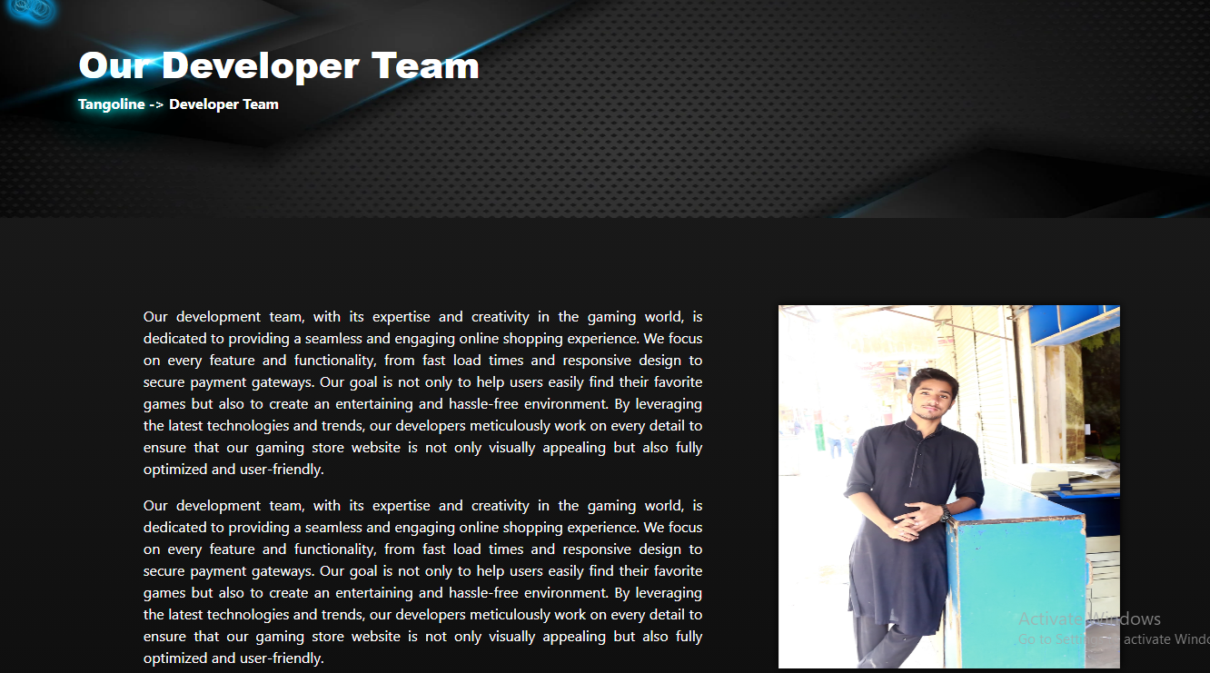

Source Code

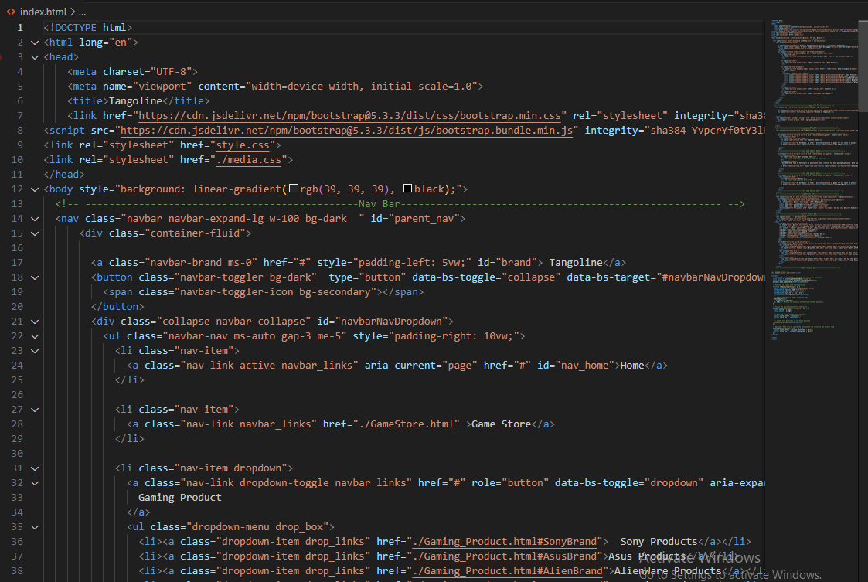

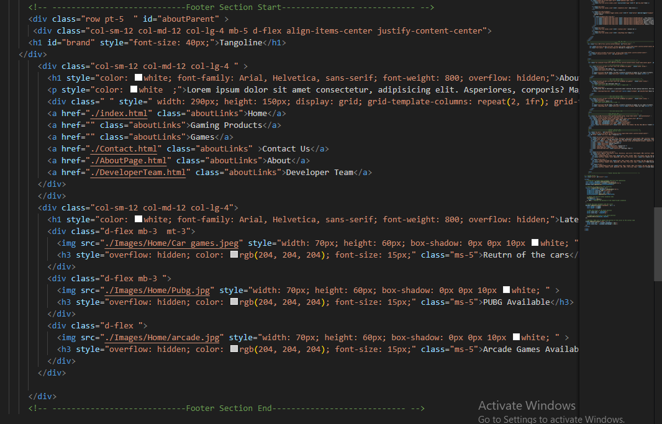

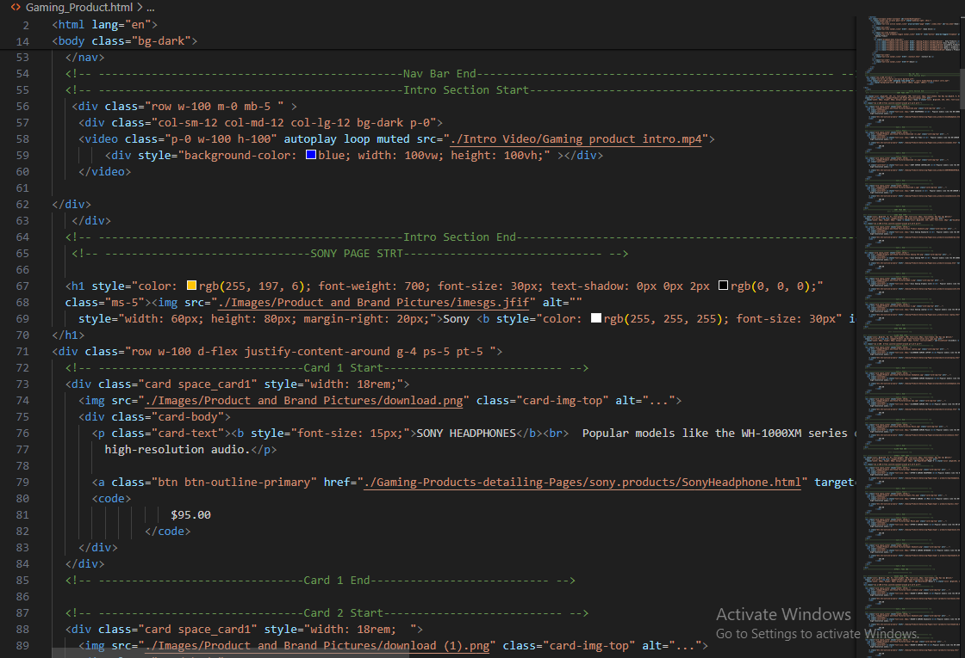

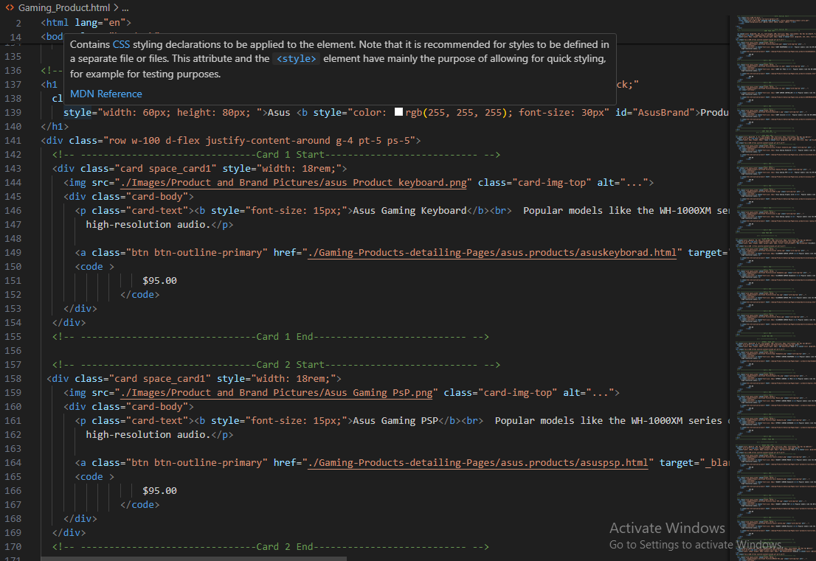

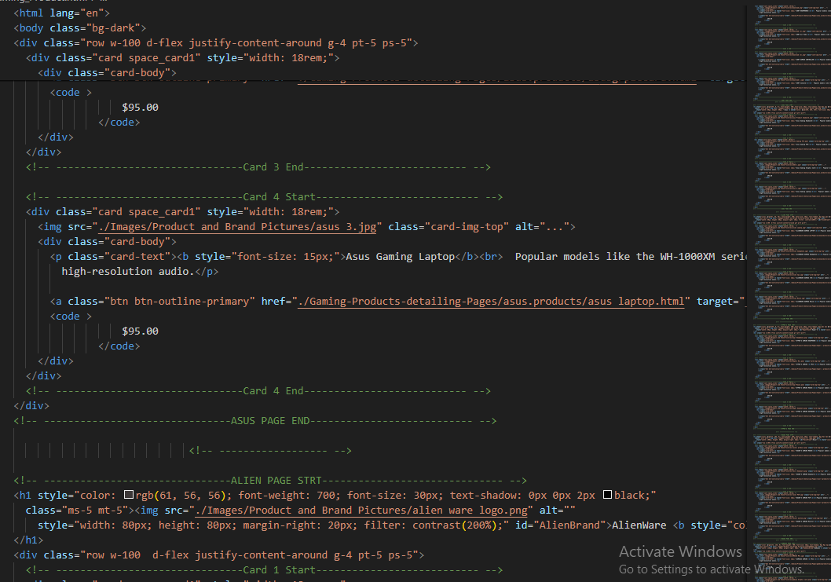

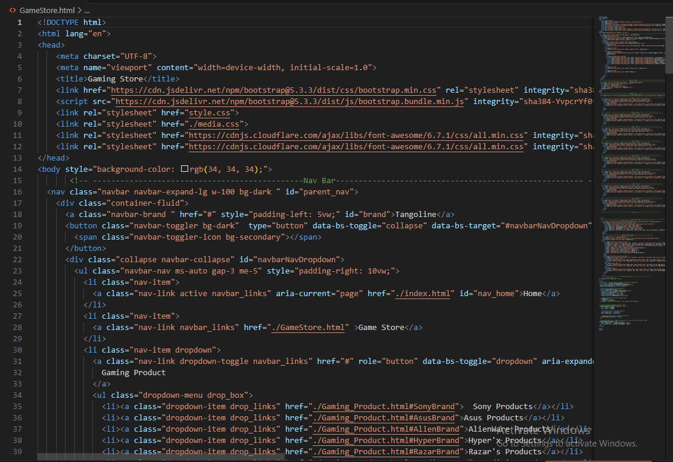

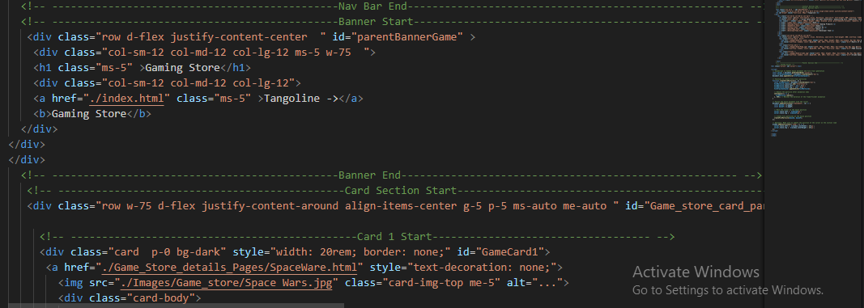

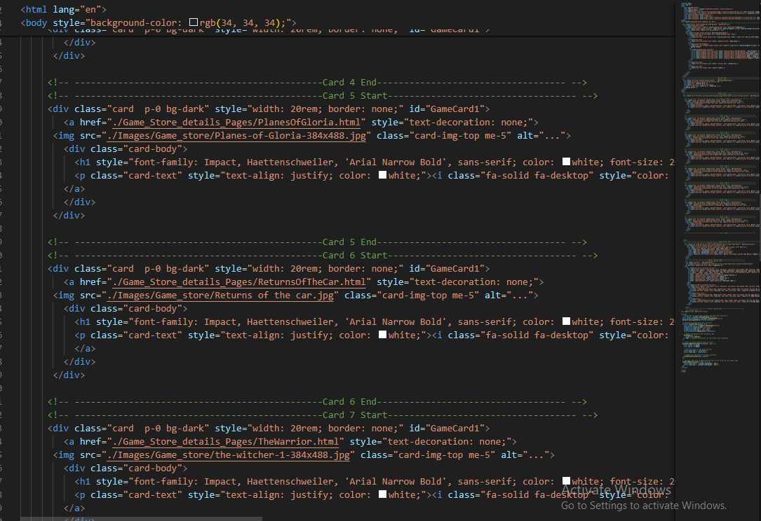

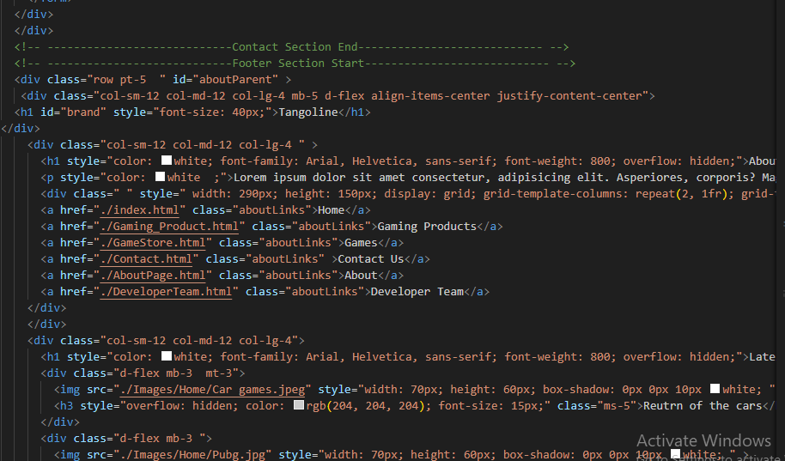

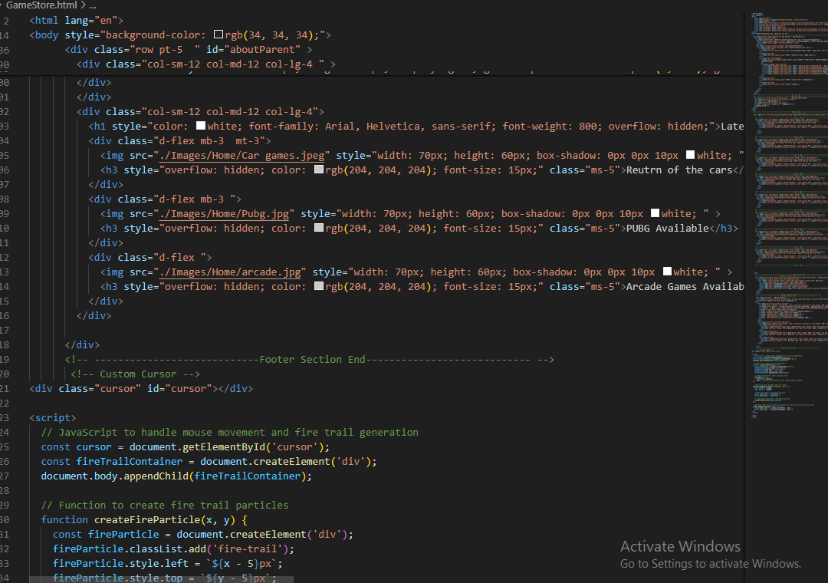 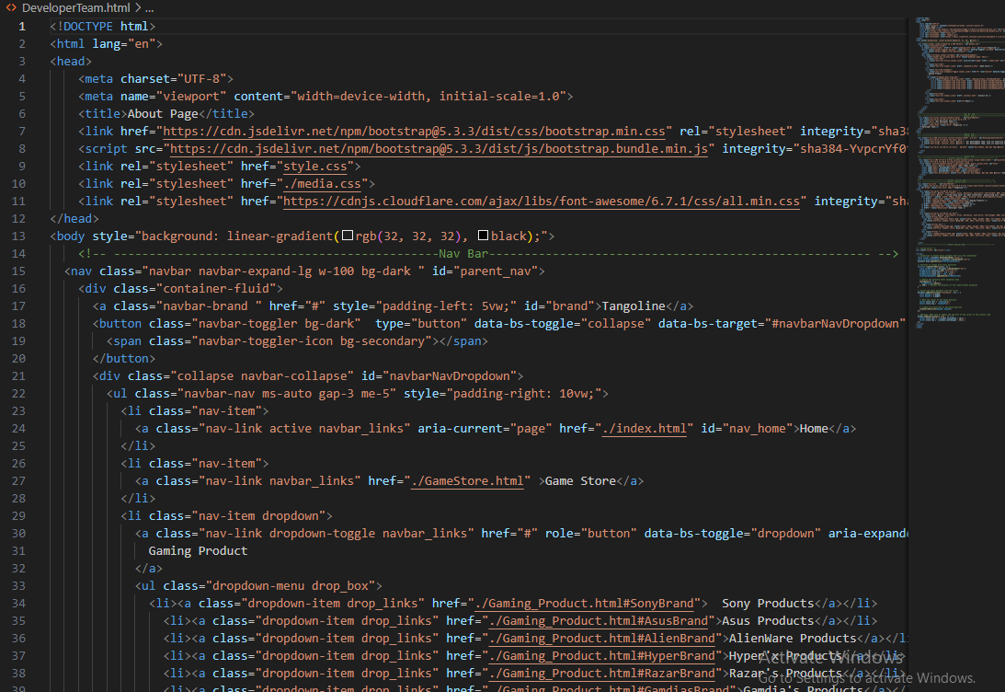

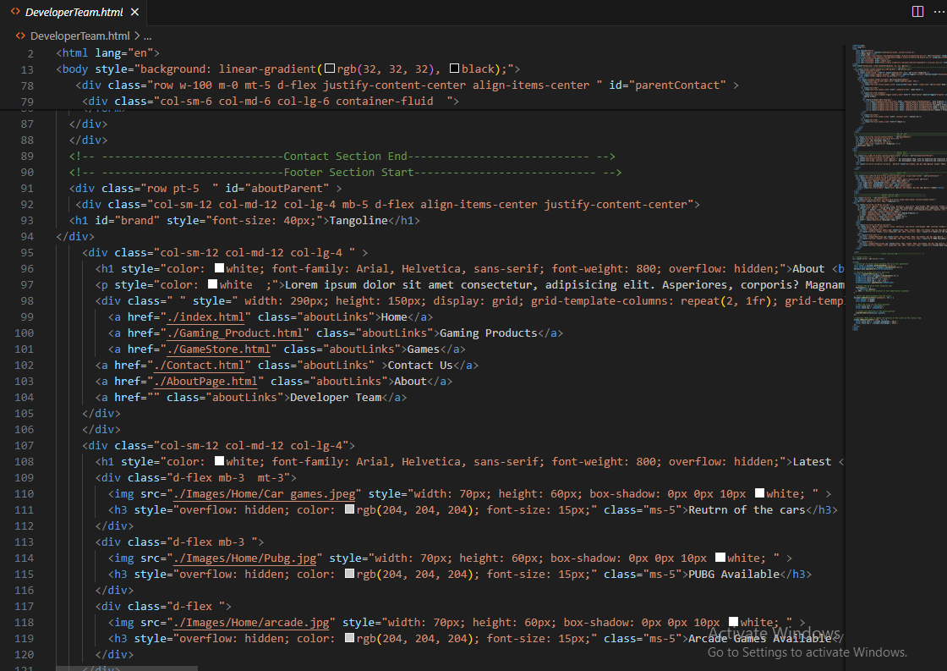

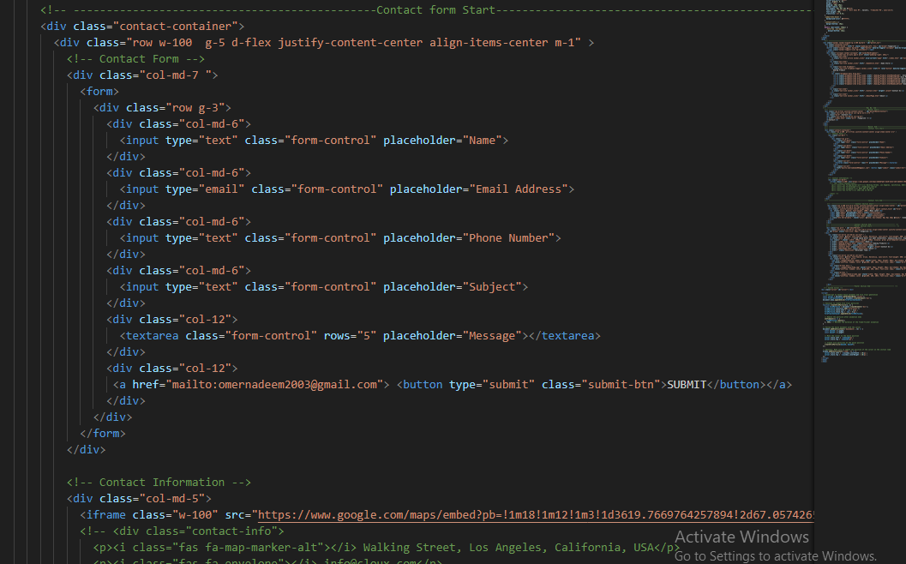

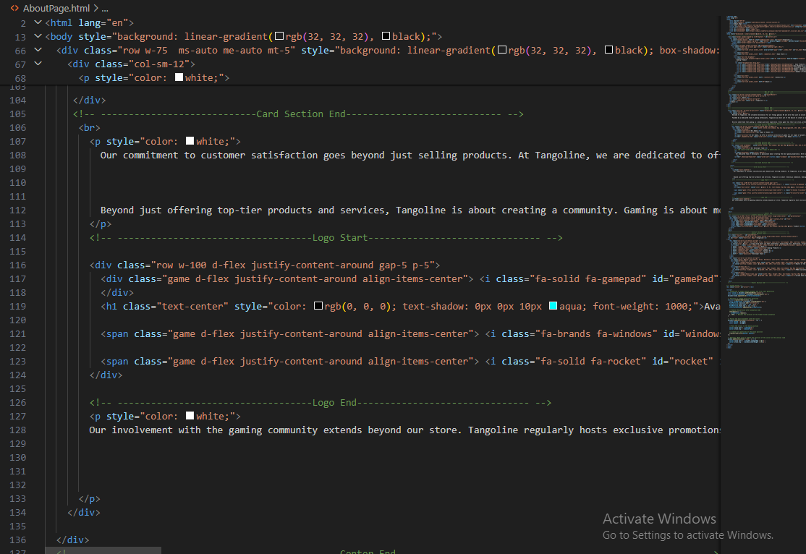

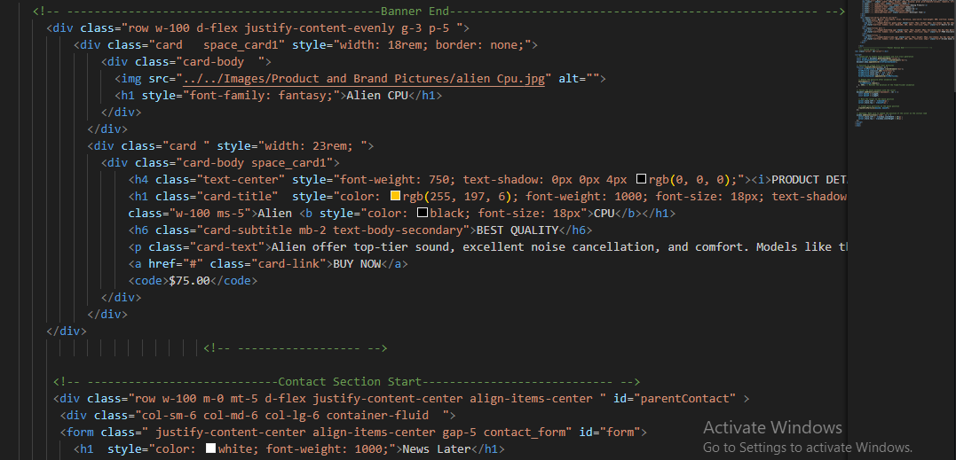

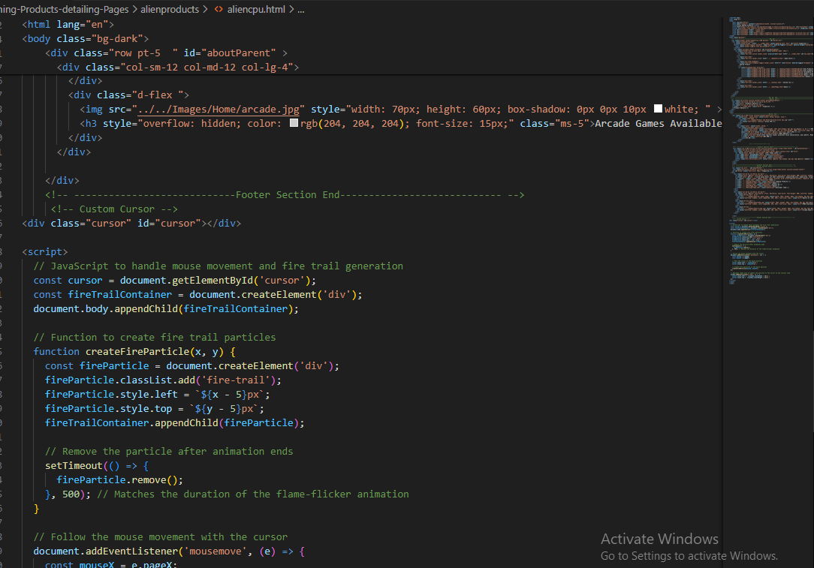

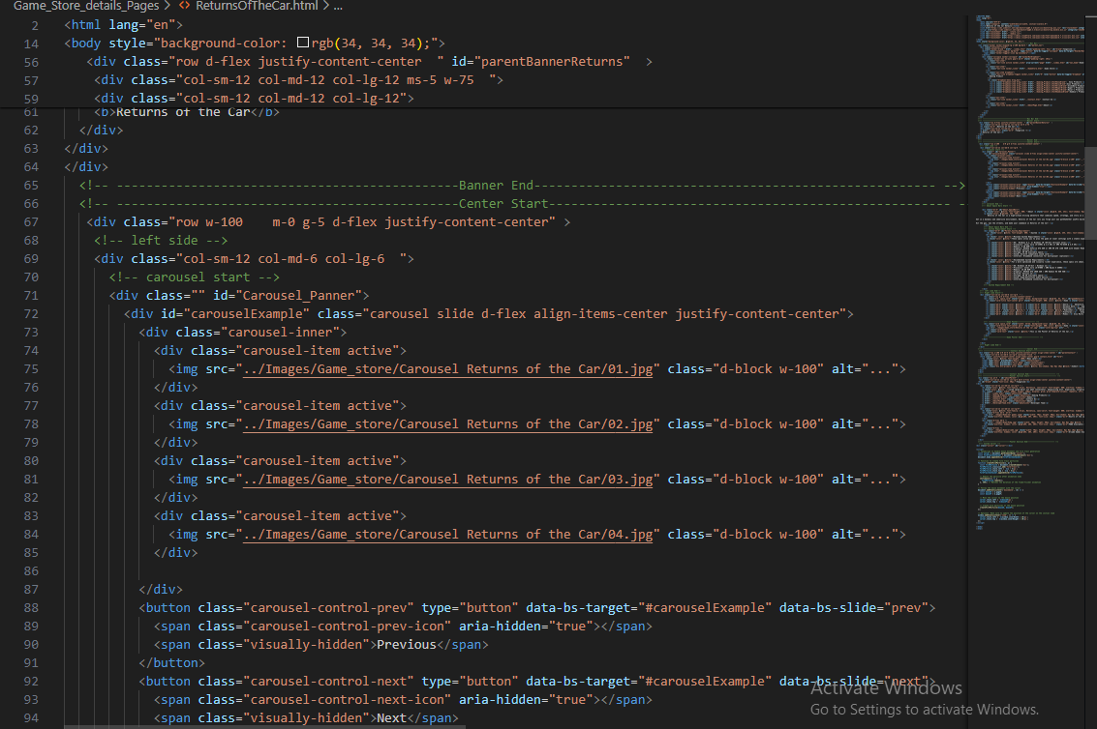

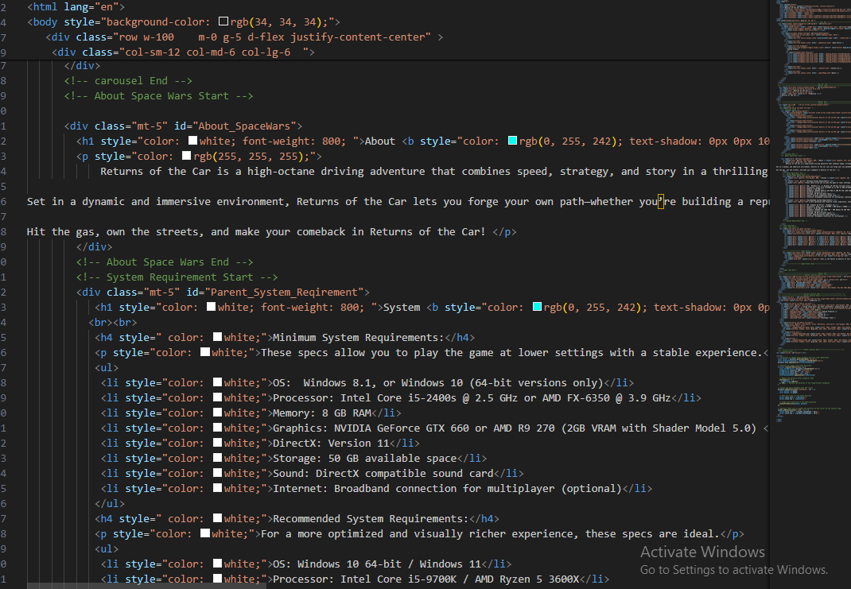

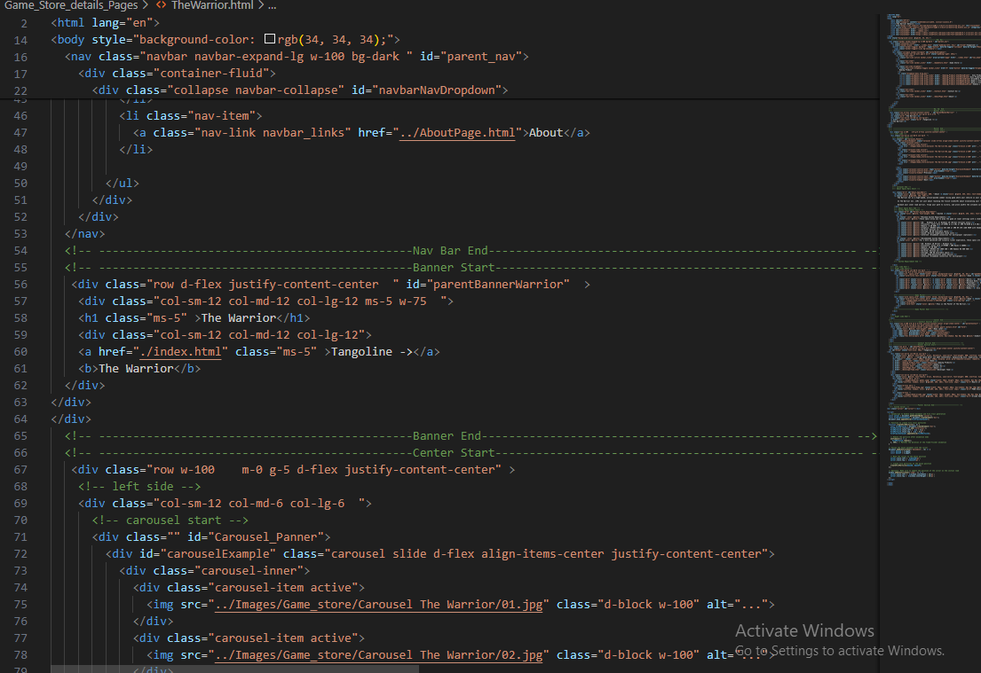

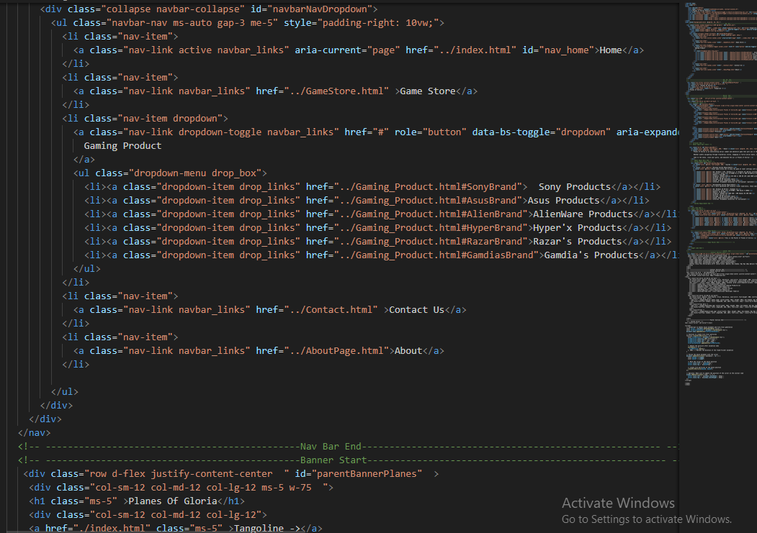

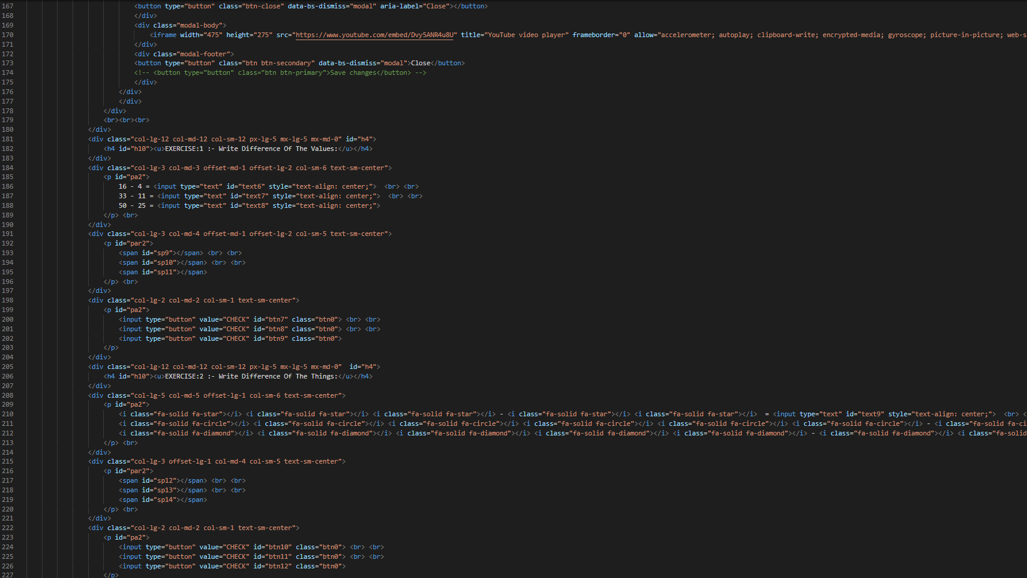

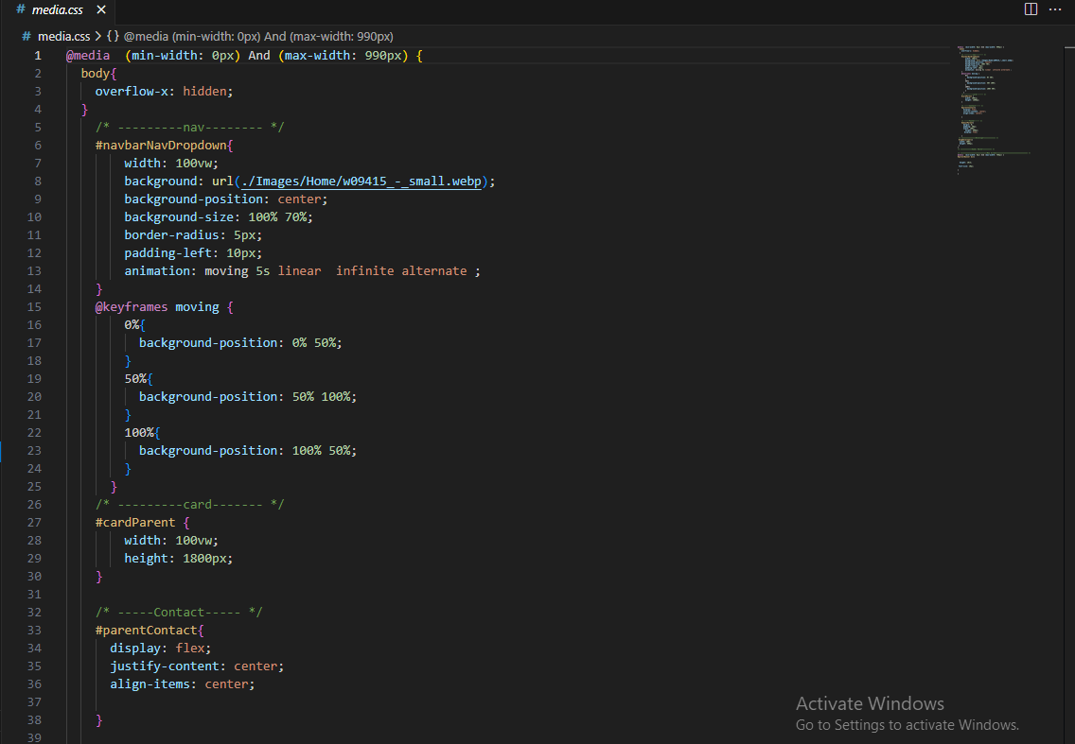

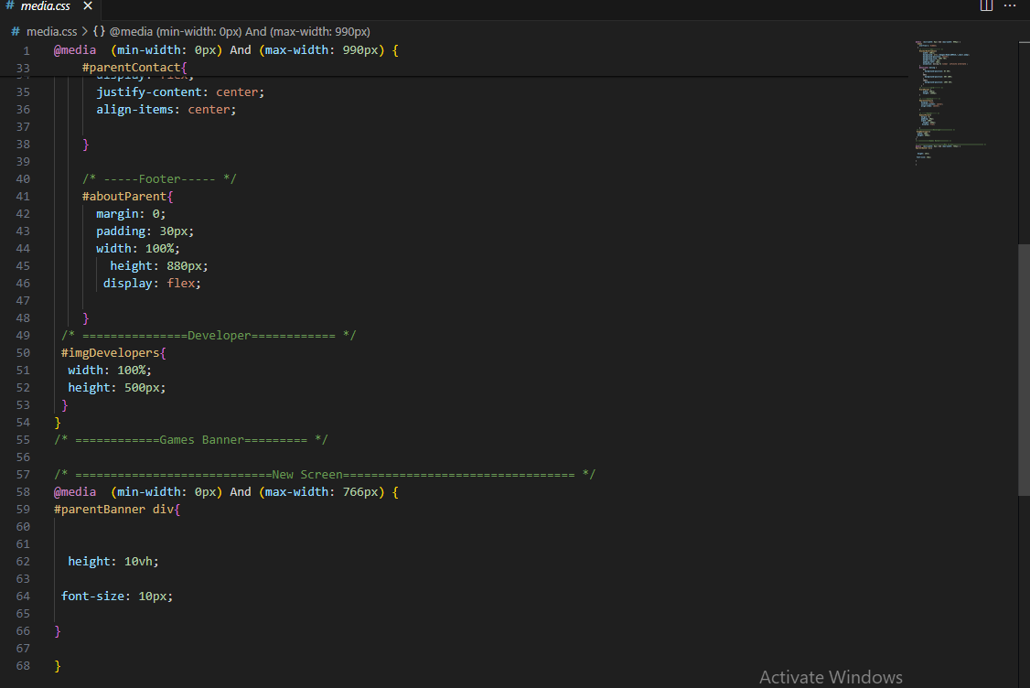

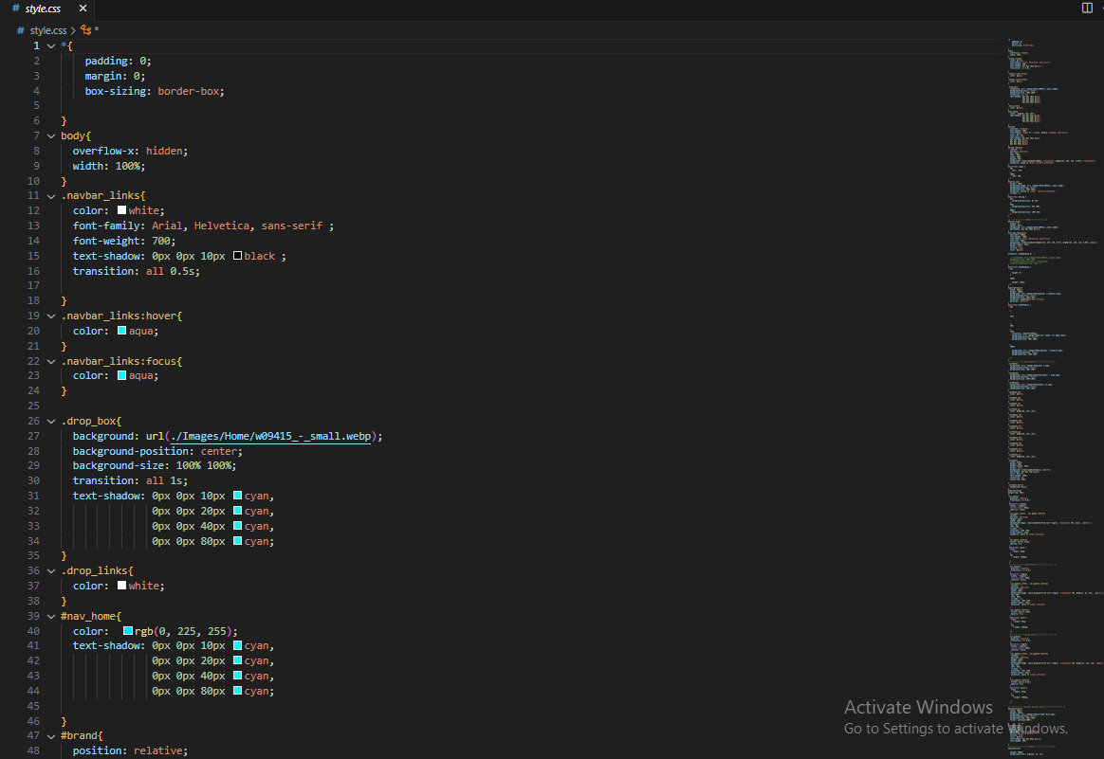

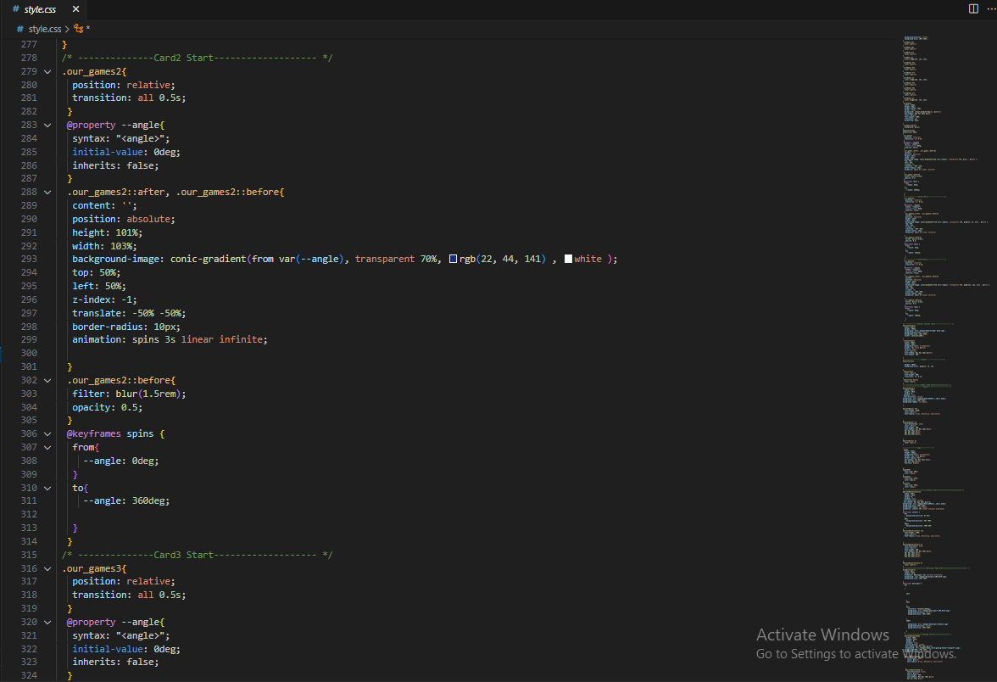

The End